Teamx

HACKATHON  PRETORIA

DECOMM

Table of Contents

DeComm WebApp Design Document. 1

Abstract 1

Key improvements. 1

Technical approach. 2

System Architecture. 2

System use case diagram 3

System sequence diagram 3

System activity diagram 4

System DFD 6

Authentication activity diagram 7

Business mode activity diagram 8

Proposed interface design 10

# DeComm WebApp Design Document.

## Abstract

This project aims to significantly enhance the existing DeComm platform, a decentralized commerce and education system developed in a previous hackathon. The improvements focus on user experience, educational features, commerce functionality, and the integration of NFTs to create a more engaging, user-friendly, and valuable platform.

## Key improvements.

* **Interactive Dashboard with Mode Switching**: Implement a dynamic dashboard that allows users to switch seamlessly between Learning (AI tutoring) and Commerce modes, providing a unified experience for education and marketplace activities.
* **Onboarding and Tutorials**: Develop an intuitive onboarding process and comprehensive tutorials to guide new users through the platform's features and functionalities.
* **Multi-Language Support**: Expand the platform's accessibility by implementing support for multiple languages, making DeComm more inclusive for a global user base.
* **Product Reviews**: Integrate a robust product review system to enhance trust and inform purchasing decisions within the marketplace.
* **Cart Purchase Progression**: Implement a clear and user-friendly cart system with visual indicators of the purchase progress, streamlining the buying process.
* **Modern UI Design**: Revamp the user interface with a sleek, modern design that maintains decentralization principles while offering an attractive and intuitive user experience.
* **FAQ and Educational Support**: Create a comprehensive FAQ section and educational resources to support users in understanding and utilizing the platform effectively.
* **Loyalty Programs and Discounts**: Develop a system for loyalty rewards and discounts to incentivize user engagement and repeated use of the platform.
* **Enhanced User Authentication**: Upgrade the authentication system by integrating Internet ID. This approach ensures secure access, preserves user privacy, and aligns with decentralization principles.
* **NFT Token Management**: Integrate NFT functionality for Knowledge Tokens, allowing users to mint, transfer, and manage NFTs representing their educational achievements and marketplace activities.

## Technical approach.

* Utilize the Internet Computer platform and Motoko programming language for backend development.
* Implement frontend improvements using Svelte for a responsive and accessible user interface.
* Leverage MOPS (Motoko Package Manager) for efficient development, particularly for NFT implementation.
* Focus on scalable and modular design to ensure easy future expansions and maintenance.

This aims to transform DeComm into a more powerful, user-friendly, and engaging platform that seamlessly integrates decentralized commerce with AI-driven education. By addressing these key areas, we strive to create a unique ecosystem that provides value to users through learning, earning, and trading in a secure and decentralized environment.

## System Architecture.

The DeComm platform integrates decentralized commerce with AI-driven education, leveraging blockchain technology for a secure and user-centric environment. The architecture consists of several key components, each managed by its own canister.

**User Canister** handles user profiles, authentication, and Knowledge Tokens, ensuring secure access via Internet ID. **Product Canister** manages product listings and inventory, while **Transaction Canister** processes and records transactions, maintaining marketplace integrity.

**Education Canister** supports AI tutoring and educational content, providing users with high-quality learning resources. **NFT Canister** manages Knowledge Tokens, allowing users to mint, transfer, and manage NFTs representing their achievements. **Frontend Canister** serves the user interface, offering a sleek, modern design with multi-language support.

Inter-canister communication ensures seamless data flow, maintaining data integrity and efficiency. This modular and scalable design allows for easy future expansions, ensuring the platform can evolve to meet user needs.

### System use case diagram

### System sequence diagram

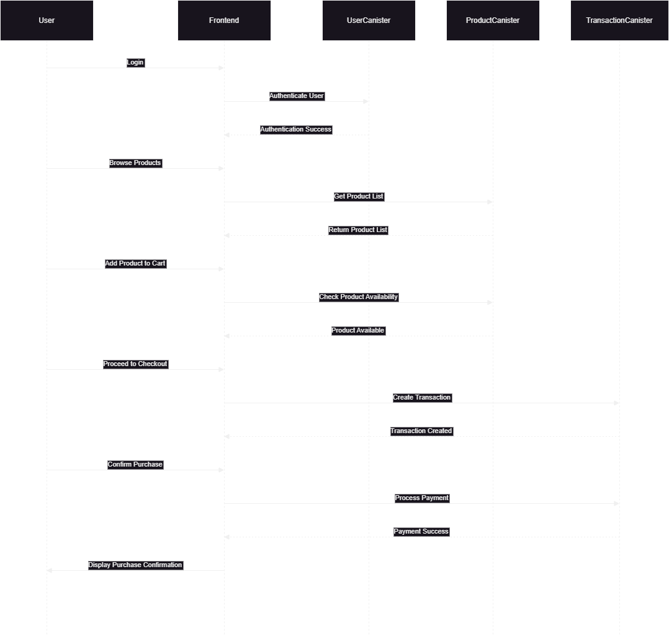

### System activity diagram

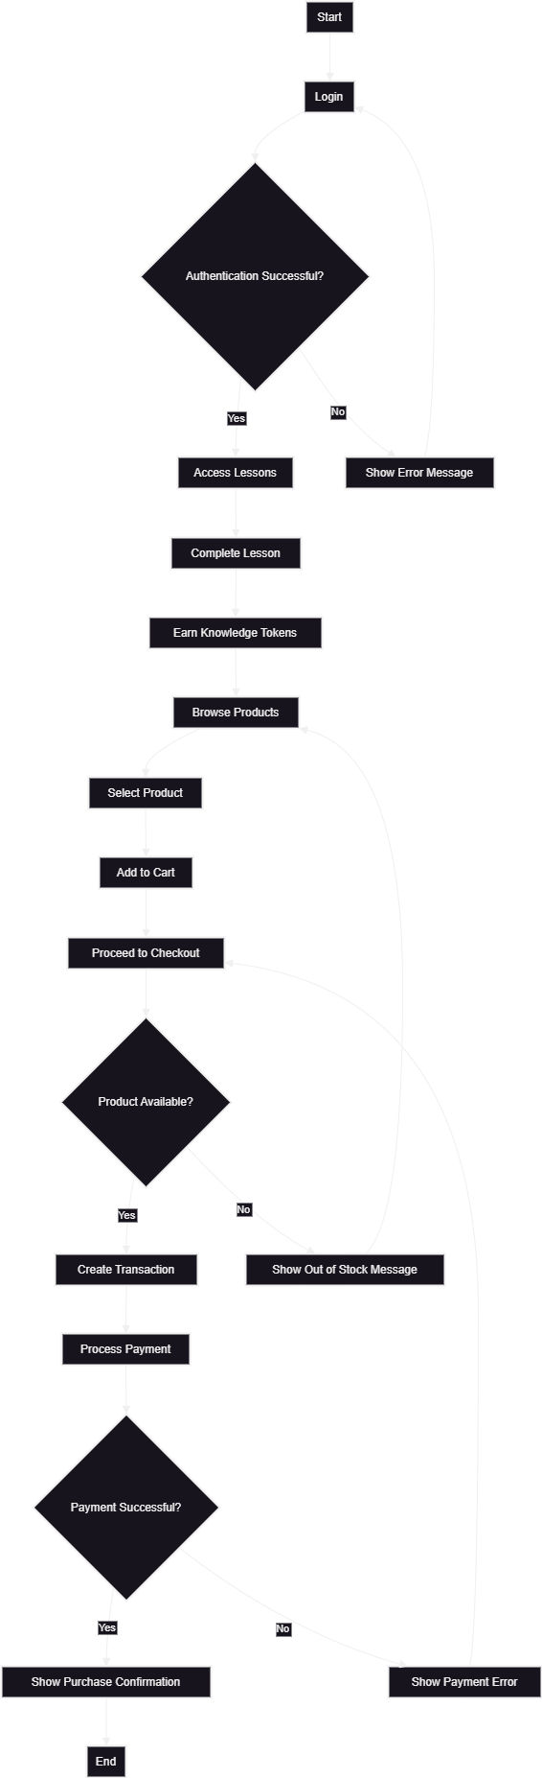

### System DFD

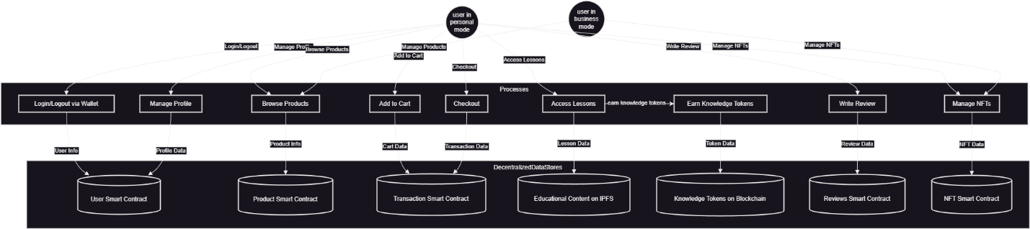

### Authentication activity diagram

### Business mode activity diagram

## Proposed interface design

The proposed interface design for the DeComm platform aims to create a visually appealing, user-friendly, and interactive web application. The design focuses on a modern, sleek aesthetic that enhances user experience while maintaining the principles of decentralization.

Key features include:

* **Interactive Dashboard**: A dynamic dashboard that allows users to seamlessly switch between Learning (AI tutoring) and Commerce modes.
* **Intuitive Onboarding**: A streamlined onboarding process with comprehensive tutorials to guide new users.
* **Modern UI Elements**: Clean, responsive design with consistent visual elements and easy navigation.
* **Multi-Language Support**: Accessibility for a global user base with support for multiple languages.
* **Product Reviews and Cart System**: User-friendly product review system and a clear cart progression indicator.

To visualize the design, here are some reference images for inspiration:

1. **Interactive Dashboard**:
2. (haven’t designed UI yet)
3. **Onboarding Process**:   
   (haven’t designed UI yet)
4. **Modern UI Elements**:
5. (haven’t designed UI yet)
6. **Product Reviews**:
7. (haven’t designed UI yet)
8. **Cart System**:
9. (haven’t designed UI yet)

These mockups and interactive elements will ensure that the DeComm platform is not only functional but also engaging and visually appealing to users.